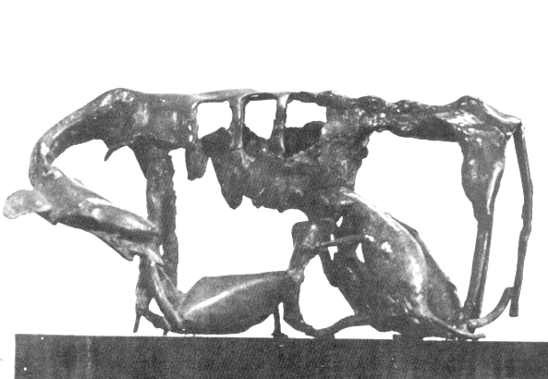

Family 1984 Bronze Somnath Hore

