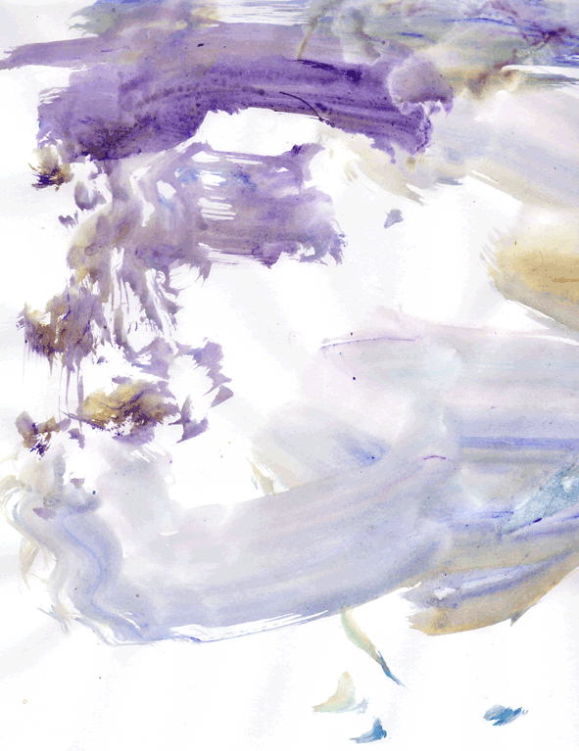

Self Portrait, Leo Minnigh
Acrylics on paper A3
March 2003

“But there is something in the modern painters that appeals to us more personally and intimately – perhaps the modern ones are deeper thinkers – I think old Millet was right when he said that men were absurd when they wish to seem other than they are. It is a common place saying, and yet it is fathomless, as deep as the ocean, and personally I think one would do well to take it to heart.” –Vincent, 21st July 1882
(About this time Vincent went out alone to explore his creative process ;-) He painted something, then reflecting ;-) wrote, -”It surprises me a little, I had expected the first things to be a failure, though I supposed they’d improve later on; but thought though I say so myself, they are not bad at all, and I repeat, it surprises me a little.”

Note to this painting: It has been my experience over the years, that people can create the most exquisite works of art, almost instantaneously as in this fine example by Leo and yet not wish to place enough value to want to keep it. I have come to understand this as a kind of creative collapse, in which I think they do intuit the greater value which is only truly realised when it is given away, freely given way.
‘Surprise’ and ‘emergence’ go together don’t they Leo, -like a ‘beginning with no end and an end with no beginning’;-)
Thank you, again for the great gift that you are and for the smaller gifts that you left with me, when you returned home.
Love,
Andrew

